Steps taken to setup a postgres database and connect to it with Django

1. Install postgres in your linux distro by running the following two commands
sudo apt-get update
sudo apt-get install python-pip python-dev libpq-dev postgresql postgresql-contrib
2. Create a database and database user

During the Postgres installation, an operating system user named postgres was created to correspond to the postgres PostgreSQL administrative user. We need to change to this user to perform administrative tasks:

sudo su - postgres

You should now be in a shell session for the postgres user. Log into a Postgres session by typing:

psql

3. Create a database for the Django project

CREATE DATABASE grdt;

4. Create a database user

CREATE USER grdtuser WITH PASSWORD 'Ytwasder2345';

5. Modify a few of the connection parameters for the user we just created

a. set the default encoding to UTF-8, which Django expects
b. We are also setting the default transaction isolation scheme to "read committed", which blocks reads from uncommitted transactions.
c. Lastly, we are setting the timezone. By default, our Django projects will be set to use UTC:

ALTER ROLE grdtuser SET client_encoding TO 'utf8';
ALTER ROLE grdtuser SET default_transaction_isolation TO 'read committed';
ALTER ROLE grdtuser SET timezone TO 'UTC';
6. Give our database user access rights to the database we created:

GRANT ALL PRIVILEGES ON DATABASE grdt TO grdtuser;

7. Exit the SQL prompt to get back to the postgres user's shell session:

\q
then type the following command to get back to your regular user’s shell
exit

8. Create your django virtualenv as usual then enable the virtualenv and run the following command to install the psycopg2 package that will allow us to use the database we configured:
pip install django psycopg2
9 Then start a django project as usual by running the following commnad:

django-admin.py startproject myproject .
(dont forget the dot)

10. Configure the Django database section
Navigate to the settings folder in “../grdt_db_manager/grdt_db_manager/settings.py”

DATABASES = {
'default': {
'ENGINE': 'django.db.backends.postgresql_psycopg2',
'NAME': 'grdt',
'USER': 'grdtuser',
'PASSWORD': 'YTwasder2345',
'HOST': 'localhost',
'PORT': '',
}
}

10. Migrate the Database and Test your Project
Make sure youiinsde your virtualenv and run the following commands:
cd ~/grdt
python manage.py makemigrations
python manage.py migrate
11. Create a django superuser by running the following commnand
python manage.py createsuperuser
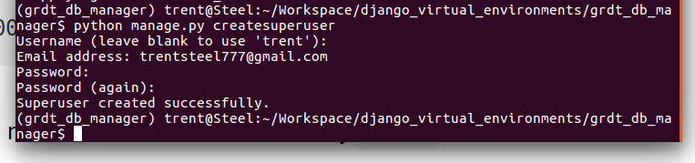
12. Test it’s working by starting the server and accessing the webpage via the broswer
python manage.py runserver

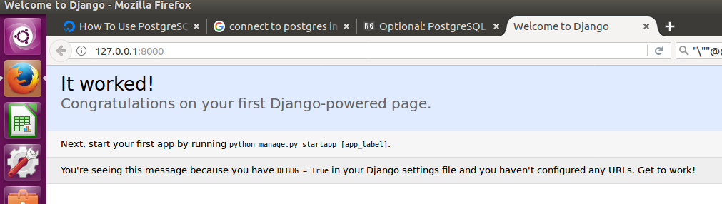
Now navigate to http://127.0.0.1:8000/admin/ and enter the credentials from the createsuperuser that was created in the previous step.

By accessing the admin interface, we have confirmed that our database has stored our user account information and that it can be appropriately accessed.

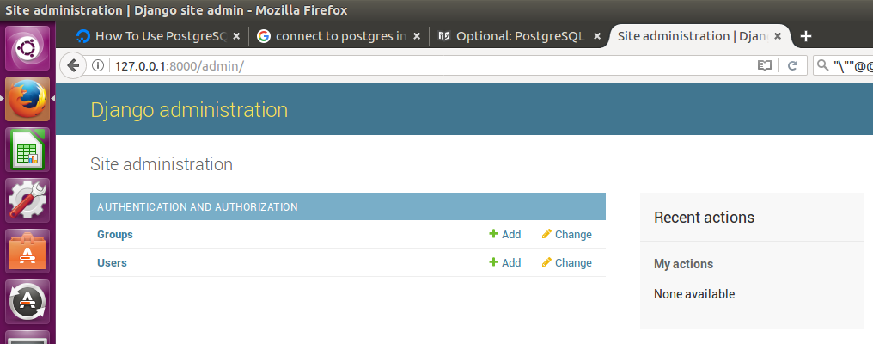
References

1. How To Use PostgreSQL with your Django Application on Ubuntu 14.04 -> https://www.digitalocean.com/community/tutorials/how-to-use-postgresql-with-your-django-application-on-ubuntu-14-04

2.PostgreSQL installation -> https://djangogirls.gitbooks.io/django-girls-tutorial-extensions/optional_postgresql_installation/

